January 9, 2020
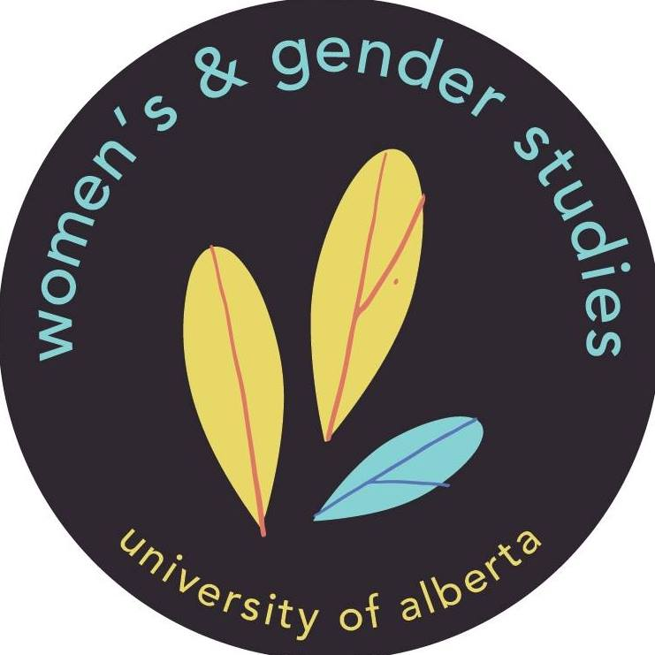
Statement of solidarity with the Wet’suwet’en

We, graduate students of the Gender and Social Justice Department at the University of Alberta, recognize that we study and live on Treaty Six territory, the ancestral, traditional and occupied territories of the Blackfoot, Cree, Dene, Nakota Sioux, Saulteaux, and Métis Nations. Specifically, the University of Alberta is on the lands of the Papaschase Cree. We would like to acknowledge that we must constantly be interrogating daily, normative encounters within settler colonialism and within power structures and institutions such as the University of Alberta. This requires settlers to support Indigenous peoples in their struggles for self-determination, land reclamation and sovereignty. It is our responsibility to critically look at settler colonial histories and their contemporary implications, as well as pay respect to the caretakers of this land and the land itself and actively stand in solidarity with Indigenous peoples.

We stand with the Wet’suwet’en people, including the Unist’ot’en Camp and Gidimt’en checkpoint and their mobilization against the Coastal GasLink project.

On December 31, 2019, BC Supreme Court Justice Marguerite Church granted an injunction against members of the Wet’suwet’en nation who have been protecting their traditional territories from the destruction of multiple pipelines, including Coastal GasLink’s liquefied natural gas pipeline. Hereditary Chiefs of the five Wet’suwet’en clans have rejected Church’s decision, which criminalizes Wet’suwet’en law and self-determination. The Chiefs have issued and enforced an eviction of Coastal Gaslink workers from their territory. The last Coastal GasLink contractor was escorted out by Wet’suwet’en Chiefs on January 4, 2020. A 72-hour injunction letter was delivered Tuesday, January 7th to the Wet’suwet’en to allow Coastal GasLink workers back onto the land.

We fully support the eviction notice given by the Wet’suwet’en chiefs to Coastal GasLink contractors. Coastal GasLink is in violation of Wet'suwet'en law.

In January 2019, the RCMP violently raided Wet'suwet'en territories and criminalized Indigenous land defenders for upholding their responsibilities towards their land. We call for the immediate and ongoing withdrawal of the RCMP, Coastal GasLink, other extractive industries and the colonial government from Wet’suwet’en territory. Consultation is not consent.

We stand with the Wet’suwet’en. We firmly support their clan governance structures, their hereditary chiefs and their self-determination over their lands. We call on other academic departments, community organizations and groups to join in solidarity with the Wet’suwet’en against colonial and extractive violence.

In solidarity,
Graduate Students in Gender and Social Justice
Women’s & Gender Studies
University of Alberta

